Software Technology Foundation
2018 Mid-Term Exam
I．Multiple-Choice（60）
1. Which of the following is (are) true about client-server architecture?
Web clients can only be executed on a powerful computer.
Web servers can support only one client at a time.
(a) I only (b) None (c) II only (d) I and II

2. When compiling a Java program that contains syntax errors, the compiler will always _______
(a) ignore the syntax errors and create a compiled program without the lines containing errors.
(b) fail to complete the compilation and report a guess of what and where the errors are.
(c) fail to complete the compilation and report the exact location of each error.
(d) fix the syntax errors and complete the compilation.

3. Consider the following table.
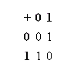
Which of the following HTML sequences can be used to lay out the preceding table?
(a) <table>
<tr> <th>+</th> <th>0</th><th>1</th> </tr>
<tr> <th>0</th> <td>0</td><td>1</td> </tr>
<tr> <th>1</th> <td>1</td><td>0</td> </tr>
</table>
(b) <table>
<td> <th>+</th> <th>0</th><th>1</th> </td>
<td> <th>0</th> <tr>0</tr><tr>1</tr> </td>
<td> <th>1</th> <tr>1</tr><tr>0</tr> </td>
</table>
(c) <table>
<th> <tr>+</tr> <tr>0</tr><tr>1</tr> </th>
<th> <tr>0</tr> <td>0</td><td>1</td> </th>
<th> <tr>1</tr> <td>1</td><td>0</td> </th>
</table>
(d) <table>
<td> <tr>+</tr> <tr>0</tr><tr>1</tr> </td>
<td> <tr>0</tr> <th>0</th><th>1</th> </td>
<td> <tr>1</tr> <th>1</th><th>0</th> </td>
</table>

4. Before a Java servlet can process a request, the Web server must first
(a) ensure the servlet is loaded and initialized
(b) restart any running instance of the servlet
(c) forward the request to the client browser
(d) formulate a response to be sent to the client browser

- What is the World Wide Web? ______________。
(a) It consists of all the computers around the world.
(b) It is a network of computers that provide multimedia information.
(c) It is a service that runs on the Internet.
(d) It is a collection of all the data accessible over the Internet.

6. A Java servlet is a program that typically runs inside which of the following?
(a) Web browser (b) Web Server
(c) Web browser and Web Server (d) None

7. A Web server and a Web client communicate using the _____ protocol.
(a) FTP (b) HTML (c) HTTP (d) URL

8. Which of the following cannot be accomplished using HTML tags?
(a) Displaying text in color
(b) Creating subscripts and superscripts
(c) Creating graphics
(d) Creating links to documents in other computers

9. The series of interactions a user has with a Web server to carry out a task is known as a ________。
(a) session (b) response (c) request (d) transaction

10、The control of a client-server transaction maintained by the Web server is known as
________。
(a) client push (b) server push (c) server pull (d) client pull

11、In an HTML FORM element, the values get and post are the only valid options for which of the following attributes? ________。
(a) method (b) enctype (c) action (d) accept

12、Consider the following URL, which corresponds to the submission of an HTML form.
http://www.carnegietech.org/search?keyword=MCQ&course=SSD1
According to the URL, the names of the two successful controls in the submitted form are
(a) keyword and course (b) search and GET
(c) search and HTTP (d) MCQ and SSD1

13、Which of the following path formats can be used to specify the value of the href attribute of the <a> tag?
- An absolute path
- A relative path
(a) II only (b) I and II (c) I only (d) None

14、Valid Java comments include which of the following?
- /* this is an /* embedded */ comment */
- /* this is an // embedded // comment */
- // this is a comment */
(a) I and II only (b) II and III only (c) I and III only (d) I only

15、Which word below is not the keyword in Java?___________。
A. private B. class C. subclass D. public

16、Valid Java identifiers include which of the following?
- _$4dollar
- $_4dollar
- 4_dollar
(a) III only (b) I, II, and III (c) None (d) I and II only

17、When programming a Java applet, a programmer creates a(n) _____ file, which a Java compiler translates into a(n) _____ file.
(a) source code, HTML (b) source code, bytecode
(c) bytecode, source code (d) HTML, bytecode

18、Consider the following Java program segment.
int i = 3;
int j = 2;
if ( (j < 0) && (i > 1) )
i = i * 2;
else
j = j - 1;

At the end of execution of the program segment, the values of variables i and j will be, respectively
(a) 3 and 2 (b) 3 and 1 (c) 6 and 1 (d) 6 and 2

19、How many ".class" files will be generated after a successful compilation of any ".java" file?
(a) At most one (b) None (c) At least one (d) Exactly one

20、Which of the following statements is (are) true about the submission of HTML forms to a Web server?
Name-value pairs are sent for a form control only if the control is successful.
A form may have more than one submit button.
(a) I and II (b) II only (c) None (d) I only

II．True (T) or False (F) Questions （10）
1. An absolute Uniform Resource Locator includes a list of permitted Web browsers.
2. A link in a Web page is a picture or text that takes your browser to another location when you click on it.
3. The fundamental job of a Java programmer is providing class definitions, or descriptions of how objects in each class must behavior.
4. The tags <UL > </UL> are used for an unordered list.
5. Model elements in Java programs are called classes. Classes that share a common behavior can be grouped into distinct categories called objects.

III．Read the codes and then answer questions. (10)
1、for (int i=0; i<3; i++) {
for (int j=0; j<2; j++) {
if ( i == j ) {
System.out.println("i==j="+i);
}
System.out.println("i="+ i + ", j=" + j + "; ");
}
}
what is the output?
i==j=0
i=0,j=0;
i=0,j=1;
i=1,j=0;
i==j=1
i=1,j=1;
i=2,j=0;
i=2,j=1;
（注意需要换行输出！）

2. <a name="#tips"><b>提示</b></a>
<a href="test.html#tips">show tips</a>
what is the main function of these codes?

IV.Fill the Blanks in the Following Codes (20)

Electronic Post Cards

Description
You are a programmer, and your boss wants you to build an HTML page from the following specifications. When you are finished, the page will feature a form and will allow individuals to design custom electronic post cards. Create a file named EPostCardsForm.html that contains a FORM element with which information will be submitted to the servlet EPostCard.class (available below). When the form is submitted to EPostCard.class, the servlet will generate an image of the post card ordered, which is then displayed in the browser window. The image of the post card ordered will feature the sender and recipient information that was submitted with the form—as well as an image, depending on which image's radio button was selected.
The file ePostCardsForm's FORM element must contain the following:
- A single-line text input control named "SenderName"
- A single-line text input control named "SenderEMail"
- A single-line text input control named "RecipientName"
- A single-line text input control named "RecipientEMail"
- A single-line text input control named "Message"A radio button input control group named "BGImage" that has labeled four options:
  - "Archways"
  - "Gondolas"
  - "Ruins"
  - "Volcanoes"
Note that the value returned by the radio buttons should be the name of the image file corresponding to the option selected. Thus, selecting "Volcanoes" should return the value "volcanoes.jpg" (notice that "v" is lowercase in the value returned).
- Four image controls, each next to one of the radio buttons and displaying the image that corresponds to the option's label
- A submit button labeled "Create Post Card"
In addition, the FORM should use the action "/servlet/EPostCard" and the POST method.

Files: archways.jpg、 gondolas.jpg、 ruins.jpg、 volcanoes.jpg 、EPostCard.class
See the image of an example solution provided below.
Example Solution Example Response
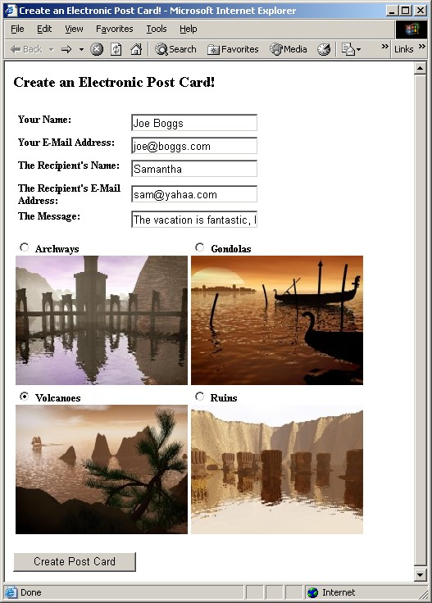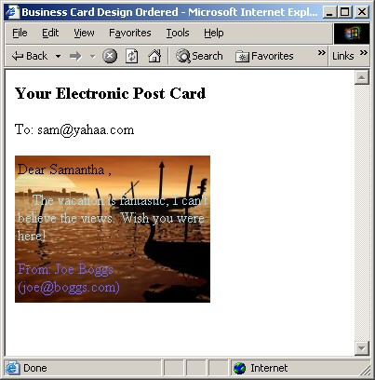

<! 1 html PUBLIC '-//W3C//DTD XHTML 1.0 Transitional//EN' 'http://www.w3.org/TR/xhtml1/DTD/xhtml1-transitional.dtd'>
<html >
<head>
2
< 3 http-equiv='Content-Type' content='text/html; charset=utf-8' />
</head>
<body>
<form 4 >
<h3>Business Card Designs</h3>
<table>
<tr>
<td >Your Name:</td>
<td ><input 5 ></td>
</tr>
<tr>
<td >Your E-Mail Address: </td>
<td><input 6 ></td>
</tr>
<tr>
<td >The Recipient’s Name: </td>
<td><input 7 ></td>
</tr>
<tr>
<td >The Recipient’s E-Mail Address: </td>
<td><input 8 ></td>
</tr>
<tr>
<td >The Message:: </td>
<td>< 9 ></td>
</tr>
</table>
<table>
<tr>
<td><label> <input type='radio' 10 >Archways </label></td>
<td><label><input type='radio' 11 >Gondolas</label></td>
</tr>
<tr>
<td><img 12 > </td>
<td><img 13 > </td>
</tr>
<tr>
<td><label> 14 Volcanoes</label></td>
<td><label> 15 Ruins </label></td>
</tr>
<tr>
<td><img 16 ></td>
<td><img 17 ></td>
</tr>
18
<br /><input 19 >
</body>
20
- DOCTYPE
- <head>Create Electronic Post Card!</head>
- meta
- action= '/servlet/EPostCard' method= 'post'
- type='text' name= 'SenderName'
- type='text' name= 'SenderEMail'
- type='text' name= 'RecipientName'
- type='text' name= 'RecipientEMail'
- type='text' name= 'Message'
- name='BGImage' value='archways.jpg'
- name='BGImage' value='gondolas.jpg'
- src='archways.jpg'
- src='gondolas.jpg'
- <input type='radio' name='BGImage' value='ruins.jpg'>
- <input type='radio' name='BGImage' value='volcanoes.jpg'>
- src='ruins.jpg'
- src='volcanoes.jpg'
- </table>
- <type='submit' value='Create Post Card'>
- </form>

I．Multiple-Choice
1. B 2. B 3. A 4. A 5. C 6. B 7. C 8. C 9. A 10. B
11. A 12. A 13. B 14. B 15. C 16. D 17. B 18. B 19. C 20. A

- DOCTYPE
- <head>Create Electronic Post Card!</head>
- meta
- action= '/servlet/EPostCard' method= 'post'
- type='text' name= 'SenderName'
- type='text' name= 'SenderEMail'
- type='text' name= 'RecipientName'
- type='text' name= 'RecipientEMail'
- type='text' name= 'Message'
- name='BGImage' value='archways.jpg'
- name='BGImage' value='gondolas.jpg'
- src='archways.jpg'
- src='gondolas.jpg'
- <input type='radio' name='BGImage' value='ruins.jpg'>
- <input type='radio' name='BGImage' value='volcanoes.jpg'>
- src='ruins.jpg'
- src='volcanoes.jpg'
- </table>
- <type='submit' value='Create Post Card'>
- </form>

